**Data RepresentationLab 2: Functionality on the webpage**

**Lecturer: Andrew Beatty**

**Student: Etain Upton G00318876**

1. Done;

<html>

    <head>

        <title>View cars</title>

        <link rel="stylesheet" href="https://stackpath.bootstrapcdn.com/bootstrap/4.3.1/css/bootstrap.min.css" integrity="sha384-ggOyR0iXCbMQv3Xipma34MD+dH/1fQ784/j6cY/iJTQUOhcWr7x9JvoRxT2MZw1T" crossorigin="anonymous">

    </head>

    <body>

        <h1>Cars</h1>

        <div><button>Create</button></div>

        <div><h1>All Cars</h1></div>

        <div>

        <table class="table">

            <tr>

                    <th>reg</th>

                    <th>make</th>

                    <th>model</th>

                    <th>price</th>

                    <th>Update</th>

                    <th>Delete</th>

            </tr>

            <tr>

                    <td>191 MO 123</td>

                    <td>Ford</td>

                    <td>Mondeo</td>

                    <td>25,000</td>

                    <td><button>Update</button></td>

                    <td><button>Delete</button></td>

            </tr>

            <tr>

                    <td>131 G 456</td>

                    <td>Ford</td>

                    <td>Fiesta</td>

                    <td>15,000</td>

                    <td><button>Update</button></td>

                    <td><button>Delete</button></td>

            </tr>

            <tr>

                    <td>192 G 111</td>

                    <td>Audi</td>

                    <td>A6</td>

                    <td>40,000</td>

                    <td><button>Update</button></td>

                    <td><button>Delete</button></td>

            </tr>

        </table>

        </div>

        <div id='CreateUpdateForm' style="display: none">

            <h2><span>Create a</span> <span>Update this</span> Car</h2>

        </div>

                    Reg <input type="text" name="reg"><br/>

                    Make <select name="make">

                            <option value="Ford">Ford</option>

                            <option value="Ford">Ford</option>

                            <option value="Audi">Audi</option>

                        </select><br/>

                    Model <input type="text" name="model"><br/>

                    Price <input type="number" name="price"><br/>

                    <span><button>Create</button></span>

                    <span><button>Delete</button></span>

                    </select>

    </body>

</html>

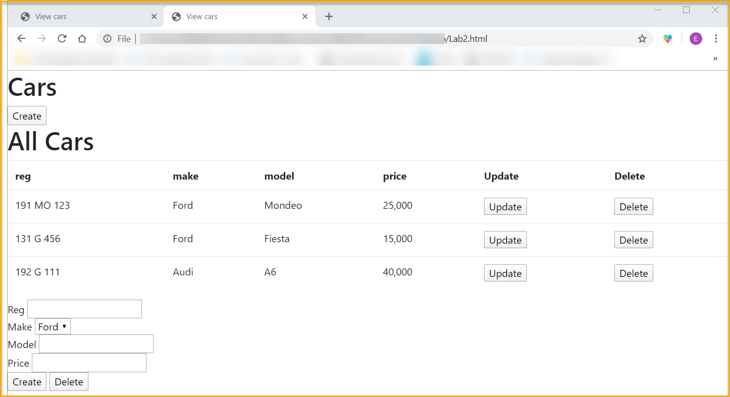

1. Done;

<html>

    <head>

        <title>View cars</title>

        <link rel="stylesheet" href="https://stackpath.bootstrapcdn.com/bootstrap/4.3.1/css/bootstrap.min.css" integrity="sha384-ggOyR0iXCbMQv3Xipma34MD+dH/1fQ784/j6cY/iJTQUOhcWr7x9JvoRxT2MZw1T" crossorigin="anonymous">

    </head>

    <body>

        <h1>Cars</h1>

        <button id="showCreateButton"></button>

        <div><button>Create</button></div>

        <div><h1>All Cars</h1></div>

        <div>

                <table class="table" id="varTable">

        <table class="table">

            <tr>

                    <th>reg</th>

                    <th>make</th>

                    <th>model</th>

                    <th>price</th>

                    <th>Update</th>

                    <th>Delete</th>

            </tr>

            <tr>

                    <td>191 MO 123</td>

                    <td>Ford</td>

                    <td>Mondeo</td>

                    <td>25,000</td>

                    <td><button>Update</button></td>

                    <td><button>Delete</button></td>

            </tr>

            <tr>

                    <td>131 G 456</td>

                    <td>Ford</td>

                    <td>Fiesta</td>

                    <td>15,000</td>

                    <td><button>Update</button></td>

                    <td><button>Delete</button></td>

            </tr>

            <tr>

                    <td>192 G 111</td>

                    <td>Audi</td>

                    <td>A6</td>

                    <td>40,000</td>

                    <td><button>Update</button></td>

                    <td><button>Delete</button></td>

            </tr>

        </table>

        </div>

            <h2><span>Create a</span> <span>Update this</span> Car</h2>

        </div>

                    Reg <input type="text" name="reg"><br/>

                    Make <select name="make">

                            <option value="Ford">Ford</option>

                            <option value="Ford">Ford</option>

                            <option value="Audi">Audi</option>

                        </select><br/>

                    Model <input type="text" name="model"><br/>

                    Price <input type="number" name="price"><br/>

                    <span><button>Create</button></span>

                    <span><button>Delete</button></span>

                    </select>

    </body>

</html>

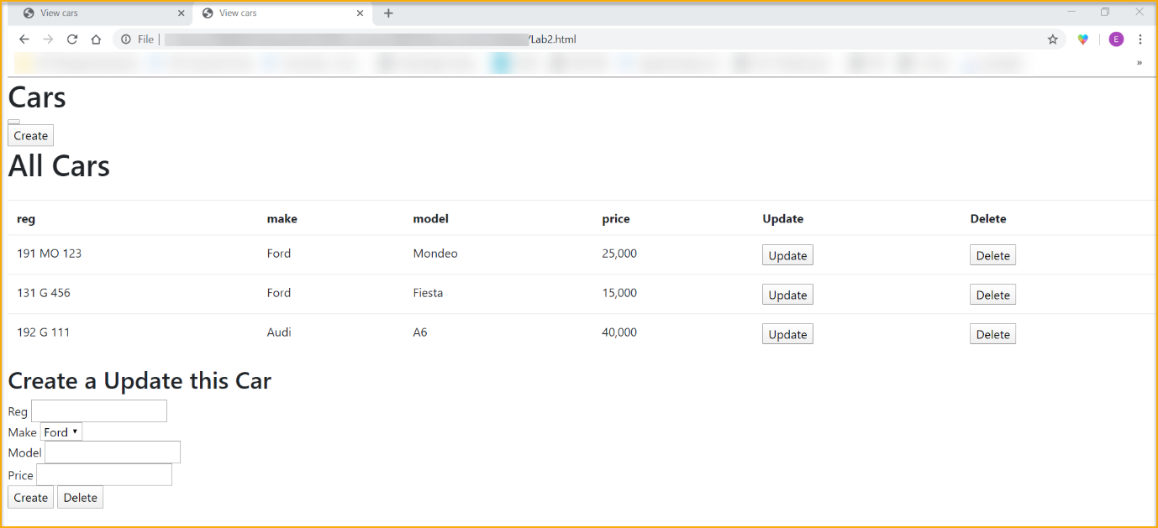

1. Done;

Stopped here – stuck.

Stopped video @ 14.35 <https://web.microsoftstream.com/video/3cd244be-1617-4228-b548-98754442e772?list=studio>